**A survey about the factors affect students' Mathematical Analysis grade/ 一份关于影响学生数学分析成绩的调查问卷**

第9题：What range is of your grade of the first examination this semester at?[avg——average grade]/ 您这学期第一次数学分析考试的成绩区间？[avg——平均成绩] [单选题]

|  |  |  |  |  |  |  |  |
| --- | --- | --- | --- | --- | --- | --- | --- |
| X\Y | [0, avg - 20) | [avg - 20, avg - 10) | [avg - 10, avg) | [avg, avg + 10) | [avg + 10, avg + 20) | [avg + 20, 100] | 小计 |
| Period 1-2/ 1-2节/Period 1-2/ 1-2节 | 2(10.53%) | 0(0%) | 4(21.05%) | 5(26.32%) | 4(21.05%) | 4(21.05%) | 19 |
| Period 1-2/ 1-2节/Period 3-4/ 3-4节 | 0(0%) | 0(0%) | 3(30%) | 4(40%) | 3(30%) | 0(0%) | 10 |
| Period 3-4/ 3-4节/Period 1-2/ 1-2节 | 1(7.14%) | 0(0%) | 5(35.71%) | 3(21.43%) | 2(14.29%) | 3(21.43%) | 14 |
| Period 3-4/ 3-4节/Period 3-4/ 3-4节 | 2(11.76%) | 2(11.76%) | 3(17.65%) | 2(11.76%) | 5(29.41%) | 3(17.65%) | 17 |

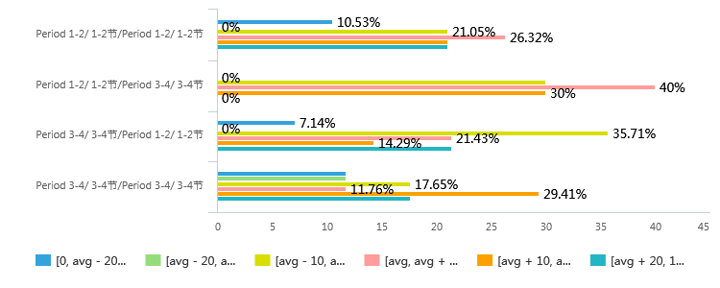

第10题：What range is your grade of the mid-term examination last semester at?/ 您上学期期中考试(第二次考试)的成绩区间？[avg——平均成绩] [单选题]

|  |  |  |  |  |  |  |  |
| --- | --- | --- | --- | --- | --- | --- | --- |
| X\Y | [0, avg - 20) | [avg - 20, avg - 10) | [avg - 10, avg) | [avg, avg + 10) | [avg + 10, avg + 20) | [avg + 20, 100] | 小计 |
| Period 1-2/ 1-2节/Period 1-2/ 1-2节 | 0(0%) | 2(10.53%) | 3(15.79%) | 8(42.11%) | 2(10.53%) | 4(21.05%) | 19 |
| Period 1-2/ 1-2节/Period 3-4/ 3-4节 | 1(10%) | 0(0%) | 2(20%) | 3(30%) | 4(40%) | 0(0%) | 10 |
| Period 3-4/ 3-4节/Period 1-2/ 1-2节 | 1(7.14%) | 2(14.29%) | 3(21.43%) | 3(21.43%) | 5(35.71%) | 0(0%) | 14 |
| Period 3-4/ 3-4节/Period 3-4/ 3-4节 | 1(5.88%) | 0(0%) | 7(41.18%) | 6(35.29%) | 2(11.76%) | 1(5.88%) | 17 |

